Ai Video Analytics For CCTV  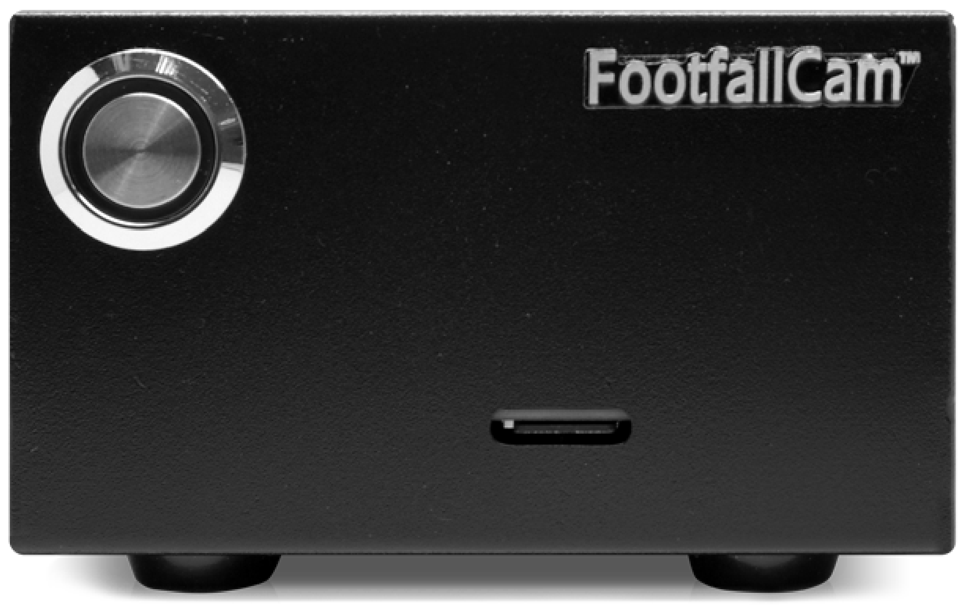  CENTROIDTM  Product Code: FC-FCT01  KEY FEATURES  - Real time processing data  - Designed for human and vehicle detection  - Process up to eight HD full-motion video streams  - Low-power edge intelligent video analytics  - FootfallCam Centroid works in conjunction with FootfallCam people counter and/or any CCTV cameras  - Data Metrics involved in the FootfallCam people counter can be computed by FootfallCam Centroid  MULTI STREAM VIDEO ANALYSIS  - Can be connected to up to 8 CCTV cameras for maximum coverage and cost-effectiveness. The videos from PoE Switch/ DVR/ NVR are processed in real time to generate in-depth data analytics. The aggregated data from each raw video stream are available to be accessed through FootfallCam Analytic Manager V9™ with read-made modules and reports.  OBJECT DETECTION (LOCALIZATION)  - Powerful processor to deploy as a low-power edge intelligent video analytics platform for Network Video Recorders (NVR), smart cameras and IoT gateways. FootfallCam Centroid™ carries out object detection and classification for any industry.  CCTV REQUIREMENTS  - Compatible processing data through Real time Streaming Protocol (RTSP)  - Allow direct video stream from RTSP enabled IP Cameras  or Network Video Recorders (NVR)  - Installed between 2 to 6 metres ceiling height with ideal mounting height between 3 to 4 metres.  - No distortion / fisheye lens on the analytic zone  - Minimum video resolution of 720p  - Minimum video frame rate of 10fps |  | GENERAL SPECIFICATION
 |  | Model | Centroid
 |  | Weight | 270 gm
 |  | Casing Colour | Black
 |  | Casing Material | Metal
 |  | Total Dimensions (mm) | 104 (W) x 81 (D) x 60 (H)
 |  | Warranty | 1 year from first allocation date (Warranty extension available upon request)
 |  | CPU | 64-bit Quad-core @ 1.43GHz
 |  | GPU | 128-core @ 921MHz
 |  | Memory | 4GB 64-bit LPDDR4 @ 1600MHz | 25.6 GB/s
 |  | Video Encoder | 4Kp30 | (4x) 1080p30 | (2x) 1080p60
 |  | Video Decoder | 4Kp60 | (2x) 4Kp30 | (8x) 1080p30 (4x) 1080p60
 |  | Processor Power | 10W
 |  | USB | 4x USB 3.0 A (Host) | USB 2.0 Micro B (Device)
 |  | Display | HDMI | DisplayPort
 |  | Networking | Gigabit Ethernet (RJ45)
 |  | Wireless | M.2 Key-E with PCIe x1
 |  | Storage | MicroSD card (16GB UHS-1 recommended minimum)
 |  | Other I/O | (3x) I2C | (2x) SPI | UART | I2S | GPIOs
 |  | Power Supply | 5V4A DC Power Adapter
 |  | Average Data Transfer Rate* | 5.0 kilobytes/hour
 |  | * Average Data Transfer Rate is measured with a predefined sample size of 20 requests per hour.
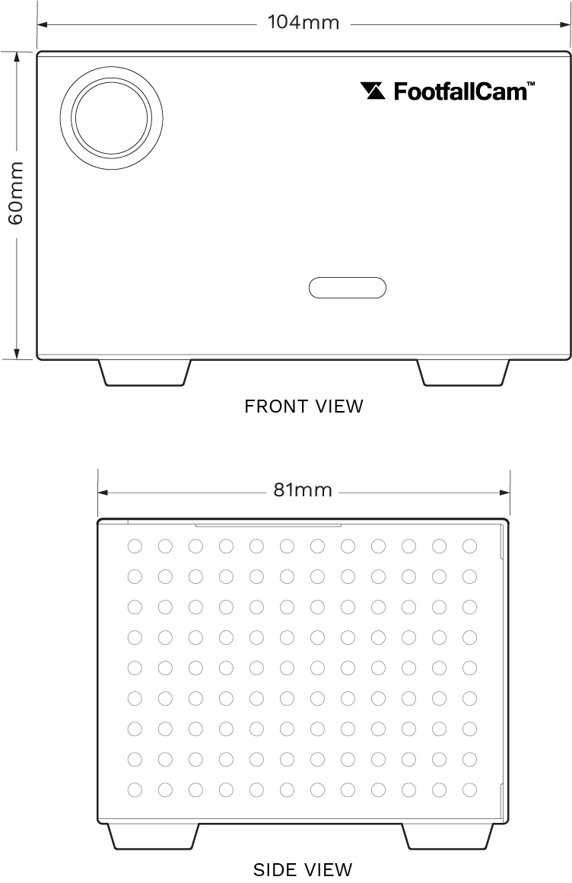
PRODUCT DIMENSION

