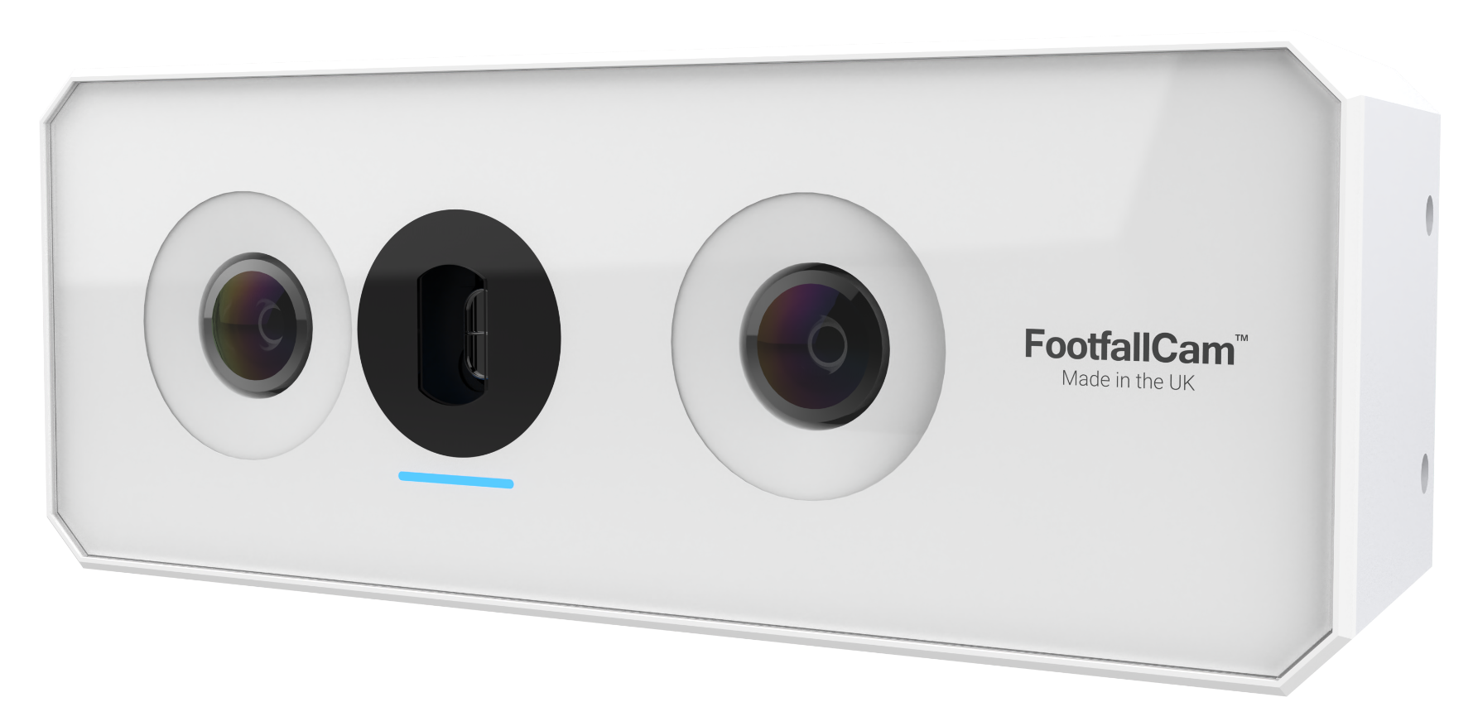
3D Stereoscopic Vision People Counter  3D PRO2TM  Product Code: FC-F3DP02  AI POWERED 3D STEREO VISION PEOPLE COUNTING  - Unparalleled Accuracy of Up to 99.5%  - Real-time Occupancy Counting  - Excellent Lifespan MBTF 25 years  - Bi-directional Counting  - Accurate Counting with Video Proof  - Superior Processing Power-Improved 3D Counting Accuracy  WIFI COUNTING  - Available metrics are outside traffic, visit duration, returning rate and traffic flow profiling.  STAFF EXCLUSION  - Staff are excluded from counting just by sewing, ironing or clipping the Staff Exclusion Tag on the shirt with no infrared or any emission involved.  OPTIMISED FOR ALL ENVIRONMENTS  - One lens fits all heights, caters for different types of stores with varying ceiling heights, as low as 2.1m to 4.5m.  - Widest Coverage. Equipped with 160 degree dual fisheye lens, reduce the total number of counters required.  - Superior Heat Dissipation. Enclosed in an aluminium unibody casing, prolong the lifespan of electronic components.  - Low-light/ Night Mode Counting with External Infrared Light  - Water Leakage-Proof. Enclosed in splash proof casing to reduce the counter failure rate due to the common issues like water leakage on the ceiling.  EASY TO INSTALL AND SET UP  - More Compact Form Factor  - 1-year Manufacturer Warranty  - GPIO Functionality. Integrate occupancy counting with all entrances and exits. |  | TECHNICAL DATA
 |  | Device Dimension (mm) | 154 (W) x 59 (D) x 40 (H)
 |  | Packing Dimension (mm) | 200 (W) x 170 (D) x 50(H)
 |  | Weight | Device: 0.4 kg Packing: 0.86 kg
 |  | Camera | 2x 5MP, 160°, 5MP omni-vision  5647 camera modules , RAM 1GB
 |  | Illumination | Minimum 1 lux (with external Infrared light source)
 |  | Frame Rate | 25 fps (Live Stream of counting will only display 320x420 resolution to reduce bandwidth sent to database for verification purpose)
 |  | Indicator | RGB LED status indicator
 |  | Casing | Made by Aluminium oxide alloy for dust resistance with 1mm tempered glass lens-covering.
 |  | IP Rating | IP64
 |  | Storage | Built-in, 8 GB Storage
 |  | Ideal Mounting Height | 2.1 metres – 4.5 metres
 |  | Operating Environment | Temperature 10°C to 45°C, Humidity 10% to 90%
 |  | Storage Environment | Temperature -40°C to 70°C, Humidity 10% to 95%
 |  | Tracking Technology | 3D-Spacing Mapping Video Tracking Technology and background removal on static objects.
 |  | Field Upgradable | Manual / Auto Software upgrade
 |  | Power Over Ethernet | Yes (IEEE802.3at)
 |  | PoE Mode | Mode A/B
 |  | Voltage | 8~56 VDC
 |  | Power Consumption | 6W
 |  | Cabling | Cat5e/Cat6, 100Mbps
 |  | Origin | Made in the UK
 |  | FIRMWARE SPECIFICATION FOR DEVICE LEVEL
 |  | Interface | Http; Https
 |  | User Levels | 2 levels: Administrator,  Standard Usery
 |  | Operating System | Footfall Counter OS
 |  | Ethernet | 10/100 Mb Ethernet
 |  | Data Delivery | TCP/IP
 |  | Database Type | SQLite
 |  | Report Format | csv, .xml, .txt
 |  | Data Storage on  counter level | Hourly Data: 300 days; Raw Data: 7 days; 3 days *Data which has sent to server will keep permanently in server level
 |  | Data Backup | Yes
 |  | Firmware Feature | Secure Operating System with Multicore Processor, Adaptive IR based on Lighting Conditions, Device Health Check, Built-in External Watchdog
 |  | Data Upload to Server | Every Hour
 |  | Average Data Transfer Rate* | 10.0 kilobytes/hour
 |  | *Average Data Transfer Rate is measured with a predefined sample size of 20 requests per hour

PRODUCT DIMENSION
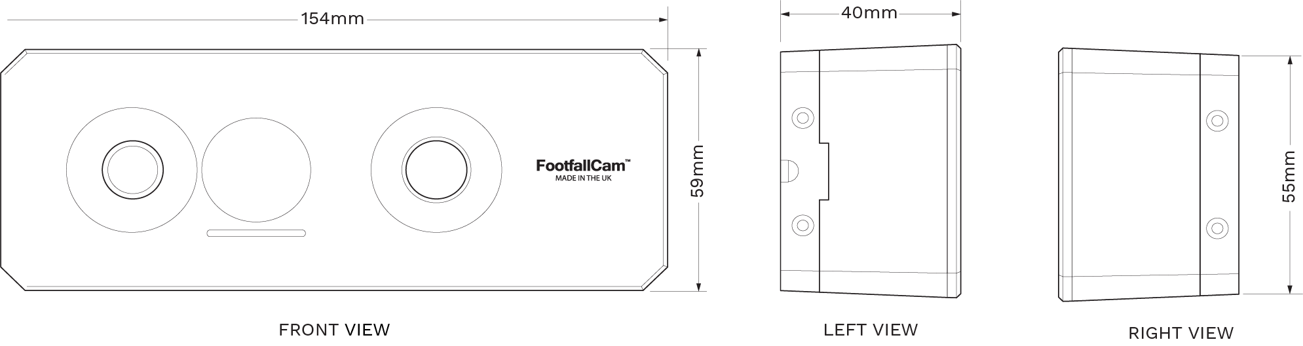

COVERAGE TABLE
Ceiling Height (m) | Lens Degree | Coverage Area (m)  (Horizontal FOV x Vertical FOV)
2.1 | 160 | 1.57 x 1.17 m
2.5 | 160 | 2.62 x 1.96 m
3.0 | 160 | 3.94 x 2.93 m
3.5 | 160 | 5.25 x 3.91 m
4.0 | 160 | 6.56 x 4.89 m
4.5 | 160 | 7.08 x 5.28 m

Notes:
1. For mounting height >4.50m, please contact sales@footfallcam.com for another mode recommendation of FootfallCam.
2. For mounting height >8.00m, recommend to use drop pole when installing the counter to the acceptable range

